  STABILIZATION |   CONTAINMENT |   INTEGRATION |   ORIENTATION |   ALIGNMENT | 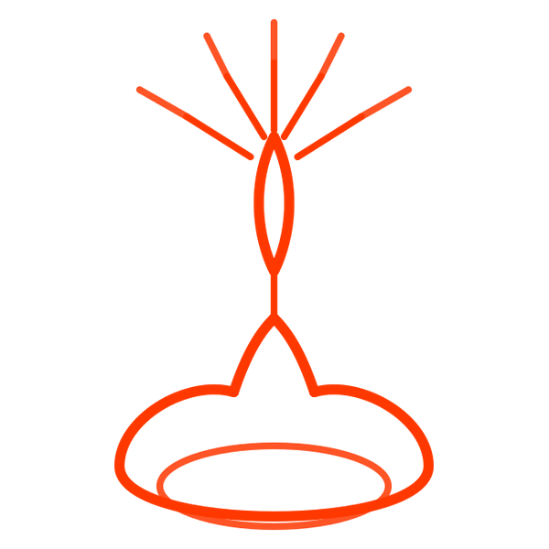  TRANSMISSION

THE VESSEL-BUILDING REFLECTION
Returning to Choice Within Real Moments
Dvora Kravitz, M.A. LMFT
A guided process for understanding your patterns and choosing your direction
────────── ◇ ──────────
This reflection helps you slow down a real moment, understand your inner responses, and gently move toward what matters to you.
Arriving
There is nothing you need to change yet.
Take a moment.
Let your body settle, even slightly.
You don’t need to figure everything out.
Just begin by noticing.
Right now, I feel:
☐ activated ☐ numb ☐ steady
What would help me stay present here?

THE PROCESS
1. The Moment
What happened?
(Stay close to the actual moment—what was said, what unfolded.)

2. The Inner Experience (What Happened Inside Me)
The Meaning
What did this moment seem to mean?

The Part of Me
Which part of me stepped in?
☐ Hurt
☐ Protective
☐ Critical
☐ Resigned
☐ Other: ______
What was it trying to do for me?

Emotions
What did I feel? (Name 1–3 emotions)

Body
What happened in my body? (tight, heavy, numb, restless, etc.)

3. What Followed
My Response
What did I do or not do?

The Outcome
What actually happened as a result?

What I Was Longing For (connection, understanding, relief, respect, space, etc.)
What did I want or need in that moment?

Did my response move me closer to what I needed?
☐ Yes ☐ A little ☐ No

4. Returning to Choice
A Different Way Forward
If this moment happened again, what might I try?

What Makes This Hard
If you pause and listen,
What is this part trying to protect me from?

A Practice Step
One small, concrete action or sentence:

Meaning & Direction
In moments like this, I want to be someone who:

Even if it feels difficult, I am choosing to move toward:

The value I want to live by here:

Closing Reflection
What am I beginning to see about myself?

This is a practice of returning. You don’t have to do this perfectly—not to automatic reactions, but to the part of you that can pause, see, and choose.

